We have the following diagram:

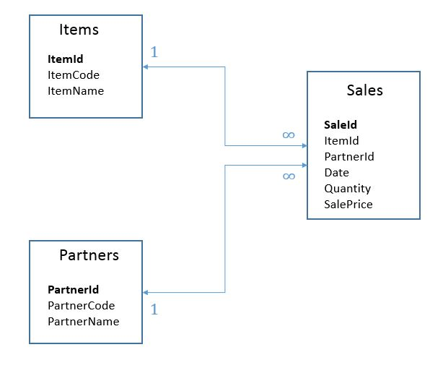 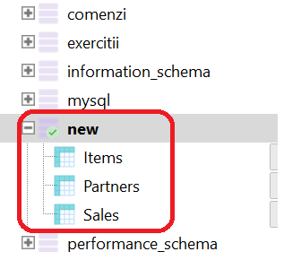

The first column from each table represents the primary key.

Sample

|  |  |  |  |  |  |  |  |  |  |
| --- | --- | --- | --- | --- | --- | --- | --- | --- | --- |
| **Items** | | |  |  |  |  |  |  |  |
| ItemId | ItemCode | ItemName |  |  |  |  |  |  |  |
| 1 | DF56R | Laptop HP |  |  |  |  |  |  |  |
| 2 | SER6G | Imprimanta |  |  |  |  |  |  |  |
| 3 | FG78R | Mouse |  |  |  |  |  |  |  |
| 4 | MNJ4L | Laptop Dell |  | **Sales** | | | | | |
| 5 | SS4F56 | Laptop Asus |  | **SaleId** | **ItemId** | **PartnerId** | **Date** | **Quantity** | **SalePrice** |
|  |  |  |  | 890734 | 1 | 100 | 2010-01-03 | 2 | 234 |
|  |  |  |  | 890734 | 3 | 100 | 2010-01-03 | 2 | 12 |
|  |  |  |  | 890735 | 4 | 234 | 2011-03-05 | 1 | 100 |
|  |  |  |  | 890735 | 1 | 234 | 2011-03-05 | 1 | 234 |
| **Partners** | | |  | 890736 | 3 | 789 | 2012-11-07 | 3 | 12 |
| **PartnerId** | **PartnerCode** | **PartnerName** |  |  |  |  |  |  |  |
| 100 | PC4567 | Gigel |  |  |  |  |  |  |  |
| 101 | AS456 | Vasilica |  |  |  |  |  |  |  |
| 102 | PC679 | Mitica |  |  |  |  |  |  |  |
| 103 | NY584 | Bobita |  |  |  |  |  |  |  |
| 104 | NY222 | Florica |  |  |  |  |  |  |  |

1. Write a query that will show the **total number** of ItemId.
2. Write a query that will show the **total number** of SaleId for each PartnerId.
3. Write a query that will show all the PartnerId for which the PartnerCode begin with NY
4. Write a query that will show the total SalePrice paid by PartnerId=100
5. Write a query that will show the Average SalePrice on March 2010.
6. Write a query that will return the **Total Sales Value** for each ItemId from Items table for JANUARY 2014.
7. Write a query that will return the **Total Sales Value** registered to the parner: “Gigel” for January 2010.
8. Write a query that will return the top 10 best-selling products from a value standpoint.
9. Delete all partners from the Partners table that don’t have any sales associated.
10. Modify the sales price for item having the ItemId **35** for all sales in the last 5 days for the partner: “Gigel”. The new sales price is **2550.**
11. Insert a new partner record in the Partners table having the PartnerId **105** and the PartnerName“**Veronica**”.
12. If we apply an index on the **Sales** table based on the column “Date”, do we increase, decrease or is there no effect on the performance of the query from point 1 of this test? Please explain why.
13. If we apply an index on the **Partners** table based on the column “PartnerCode” do we increase, decrease or is there no effect on the performance of the insert query from point 6 of this test? Please explain why.
14. Add the column MU (Measure Unit) in the table **Items**.
15. Delete the previously created column from the table **Items.**
16. Please list at least 2 differences between the functions **COALESCE** and **ISNULL**.
17. Please list at least 3 differences between **TRUNCATE**  and  **DELETE.**
18. What is the difference between **UNION** and **UNION ALL.**
19. How many clustered indexes can be defined on one table?
20. Which id value will be returned by the below select statement given the following details:

DECLARE @Logic TABLE (ID INT, Product VARCHAR(50))

INSERT INTO @Logic

VALUES (1, 'Baseball Hat'),

(2, 'Bicycle'),

(3, 'Snowboard'),

(4, 'Goggles'),

(5, 'Shows')

SELECT ID

FROM @Logic

WHERE Product = 'Bicycle' OR Product = 'Snowboard' AND ID = 4

Answer:

1. Having the following table structure what do the operators **INTERSECT** and **EXCEPT** return?

|  |  |  |
| --- | --- | --- |
| **Table_A** |  | **Table_B** |
|  |  |  |
| **Col_X** |  | **Col_Y** |
| 18 |  | 1 |
| 20 |  | 20 |
| 4 |  | 2 |
| 1 |  | 3 |
| 2 |  |  |

SELECT Col_X AS **'Intersect'**

FROM Table_A

INTERSECT

SELECT Col_Y

FROM Table_B

Answer:

SELECT Col_X AS **'Except'**

FROM Table_A

EXCEPT

SELECT Col_Y

FROM Table_B

Answer:

1. Please specify the value returned by each of the statements below:

DECLARE @a VARCHAR(10), @b VARCHAR(10), @c VARCHAR(10), @d VARCHAR(20), @e VARCHAR(20)

SET @a= 'ana'

SET @b= ' are mere'

SET @c= ' are mere '

SELECT LEN(@a) AS V1 Answer:

SELECT LEN(@b) AS V2 Answer:

SELECT LEN(@c) AS V3 Answer:

SELECT @d = @a + @c Answer:

SELECT LEN(@d) AS V4 Answer:

SELECT @e = LTRIM(RTRIM(@a)) + LTRIM(RTRIM(@c)) Answer:

SELECT LEN(@e) AS V5 Answer:

Answer: